Digital Logic First Assignment

Vedas College

VEDAS COLLEGE

Department of Computer Science and Information Technology



Submitted By

Hemanta Pokharel

Roll Number: 14

CSIT First Sem.

Submitted To

Sir Hari Pokharel

infinitivehari@gmail

**Long Questions.**

1. What are the various types of numbering system use in digital logic? Explain. Convert the ${3EC8}_{16}$ into different numbering system that you know.

Ans: The various types of numbering system used in digital logic are:

* Binary Number System
* Decimal Number System
* Octal Number System
* Hexadecimal Number System

**1) Binary Number System**

A Binary number system has only two digits that are 0 and 1. Every number (value) represents with 0 and 1 in this number system. The base of binary number system is 2, because it has only two digits.

**2) Octal number system**

Octal number system has only eight (8) digits from 0 to 7. Every number (value) represents with 0,1,2,3,4,5,6 and 7 in this number system. The base of octal number system is 8, because it has only 8 digits.

**3) Decimal number system**

Decimal number system has only ten (10) digits from 0 to 9. Every number (value) represents with 0,1,2,3,4,5,6, 7,8 and 9 in this number system. The base of decimal number system is 10, because it has only 10 digits.

**4) Hexadecimal number system**

A Hexadecimal number system has sixteen (16) alphanumeric values from 0 to 9 and A to F. Every number (value) represents with 0,1,2,3,4,5,6, 7,8,9,A,B,C,D,E and F in this number system. The base of hexadecimal number system is 16, because it has 16 alphanumeric values. Here A is 10, B is 11, C is 12, D is 13, E is 14 and F is 15.

Given number ${3EC8}_{16}$ is hexadecimal number. Now, converting the number in different number systems:

First converting the given number into decimal number system:

**Decimal Value** =3 * (16^3) + 14 * (16^2) + 12 * (16^1) + 8 * (16^0)

= 12288 + 3584 + 192 + 8

= **16072(10)**

**Binary Value**

|  |  |  |  |  |  |  |  |  |  |  |  |  |  |
| --- | --- | --- | --- | --- | --- | --- | --- | --- | --- | --- | --- | --- | --- |
| 16072 | 8036 | 4018 | 2009 | 1004 | 502 | 251 | 125 | 62 | 31 | 15 | 7 | 3 | 1 |
| 2 | 2 | 2 | 2 | 2 | 2 | 2 | 2 | 2 | 2 | 2 | 2 | 2 | 2 |
| **0** | **0** | **0** | **1** | **0** | **0** | **1** | **1** | **0** | **1** | **1** | **1** | **1** | **1** |

*Number*

*Reminder*

Hence, binary value of the given number is **11111011001000(2).**

**Octal Value**

|  |  |  |  |  |
| --- | --- | --- | --- | --- |
| 16072 | 2009 | 251 | 31 | 3 |
| 8 | 8 | 8 | 8 | 8 |
| **0** | 1 | 3 | 7 | 3 |

Hence, octal value of the given number is **37310(8).**

**Short Questions.**

1. Differentiate between Analog and Digital system.

Ans: The difference between Analog and Digital system are listed below:

|  |  |  |
| --- | --- | --- |
|  | Analog System | Digital System |
| ****Signal**** | Analog signal represents physical measurements. | Digital signals are discrete and generated by digital modulation. |
| ****Waves**** | Sine Waves | Square Waves |
| ****Representation**** | Continuous range of values to represent information | Uses discrete values to represent information |
| ****Technology**** | Records waveforms as they are. | Samples analog waveforms into a limited set of numbers and then records them. |
| ****Data transmissions**** | Affected by noise during transmission and write/read cycle. | Noise-immune during transmission and write/read cycle. |
| ****Response to Noise**** | More likely to get affected | Less likely to get affected |
| ****Flexibility**** | Hardware is not flexible. | Hardware is flexible. |
| ****Bandwidth**** | Less bandwidth. | More bandwidth to carry out the same information |
| ****Memory**** | Stored data in the form of wave signal | Stored data in the form of binary bit |
| ****Power**** | Consumes large power | Consumes negligible power |
| ****Uses**** | Best suited for audio and video transmission. | Best suited for Computing and digital electronics. |
| ****Cost**** | Cost is low | Cost is high |
| ****Example**** | Human voice in air, analog electronic devices. | Computers, CDs, DVDs, |

1. Proof the 1st and 2nd law of Demorgan's theorem with logic gate and truth table.

Ans: DeMorgan’s Theorem is mainly used to solve the various Boolean algebra expressions.The Demorgan’s theorem defines the uniformity between the gate with same inverted input and output. It is used for implementing the basic gate operation likes NAND gate and NOR gate. The Demorgan’s theorem mostly used in digital programming and for making digital circuit diagrams. There are two DeMorgan’s Theorems. They are described below in detail.

**DeMorgan’s First Theorem**

According to DeMorgan’s first theorem, a NOR gate is equivalent to a bubbled AND gate. The Boolean expressions for the bubbled AND gate can be expressed by the equation shown below. For NOR gate, the equation is

For the bubbled AND gate the equation is



As the NOR and bubbled gates are interchangeable, i.e., both gates have exactly identical outputs for the same set of inputs. Therefore, the equation can be written as shown below.

This equation (1) or identity shown above is known as DeMorgan’s Theorem. The symbolic representation of the theorem is shown in the figure below.

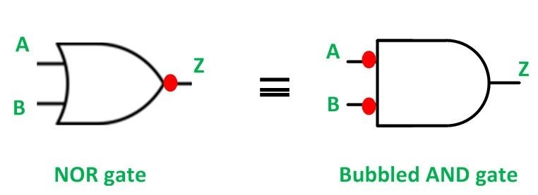

**Truth Table For Demorgan’s Theorem:**

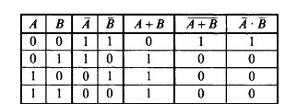

**Conclusion:** From above truth table it is proved that the value of A`. B` is equal to (A + B)`.

**.**

**DeMorgan’s Second Theorem**

It states that the complements of a products is equal to the sum of the complements of individual variable. Let X and Y be two Boolean variable then Demorgan’s theorem can be mathematically expressed as (X.Y)` = X` + Y`.

The symbolic representation of the theorem is shown in figure below:

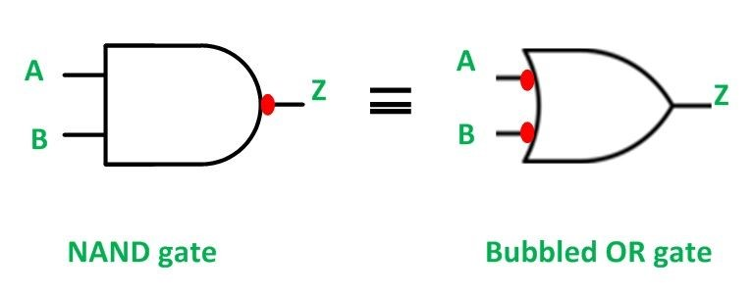

**Truth Table for Demorgan’s Second Theorem:**

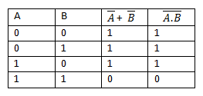

**Conclusion:** From above truth table it is proved that the value of A` + B` is equal to (A . B)`.

1. What do you mean by the Gray code? What are its application?

Ans: Gray code is an ordering of the binary numeral system such that two successive values differ in only one bit (binary digit). Gray codes are very useful in the normal sequence of binary numbers generated by the hardware that may cause an error or ambiguity during the transition from one number to the next. So, the Gray code can eliminate this problem easily since only one bit changes its value during any transition between two numbers.

Gray code is not weighted that means it does not depends on positional value of digit. This is cyclic variable code that means every transition from one value to the next value involves only one-bit change.

**The following chart shows normal binary representation from 0-5 and the corresponding gray code**

|  |  |  |
| --- | --- | --- |
| Decimal Digit | Binary Code | Gray Code |
| 0 | 0000 | 0000 |
| 1 | 0001 | 0001 |
| 2 | 0010 | 0011 |
| 3 | 0011 | 0010 |
| 4 | 0100 | 0110 |
| 5 | 0101 | 0111 |

1. Explain the duality theorem with example.

Ans: It states that “Every algebraic expression deducible from the postulates of Boolean algebra remains valid if the operators and identity elements are interchanged”.

Starting from a Boolean relation, we can derive another Boolean relation by:

1. Changing each OR(+) sign to AND(•) sign or Vice-versa
2. Complementing any 0 or 1 appearing in the expression.

Example of Duality Theorem:

1. x + 0 = x 🡺 x • 1 = x
2. x(y+z) = xy+xz 🡺 x+yz = (x+y)(x+z)

*Here: Dual of x(y+z) = x+yz and Dual of xy+xz = (x+y)(x+z)*

1. AB + A'C + BC = AB + A'C 🡺 (A+B)(A'+C)(B+C) = (A+B)(A'+C)

*Here: Dual of AB + A'C + BC = (A+B)(A'+C)(B+C) and*

*Dual of AB + A'C = (A+B)(A'+C)*

**Thus, advantage of duality theorem is that starting from one relation, another relation is obtained which is also a valid Boolean identity.**

1. Explain the error detection code with example.

Ans: Error detection codes are a sequence of numbers generated by specific procedures for detecting errors in data that has been transmitted over computer networks.

When bits are transmitted over the computer network, they are subject to get corrupted due to interference and network problems. The corrupted bits lead to spurious data being received by the receiver and are called errors.

Error detecting codes ensures messages to be encoded before they are sent over noisy channels. The encoding is done in a manner so that the decoder at the receiving end can detect whether there are errors in the incoming signal with high probability of success.

**Features of Error Detecting Codes**

* Error detecting codes are adopted when backward error correction techniques are used for reliable data transmission. In this method, the receiver sends a feedback message to the sender to inform whether an error-free message has been received or not. If there are errors, then the sender retransmits the message.
* Error-detecting codes are usually block codes, where the message is divided into fixed-sized blocks of bits, to which redundant bits are added for error detection.
* Error detection involves checking whether any error has occurred or not. The number of error bits and the type of error does not matter.

**Error Detection Techniques**

There are three main techniques for detecting errors:

* Parity Check
* Checksum
* Cyclic Redundancy Check (CRC)

**Parity Check**

Parity code is one of the most common ways to achieve error detection by means of a parity bit. A parity bit is the extra bit included to make the total number of 1’s in the resulting code word either even or odd. A message of 4 bits and parity bit P are shown in the table below:

|  |  |  |  |
| --- | --- | --- | --- |
| Odd | parity | Even | Parity |
| Message | **P** | **Message** | **P** |
| 0000 | 1 | 0000 | 0 |
| 0001 | 0 | 0001 | 1 |
| 0010 | 0 | 0010 | 1 |
| 0011 | 1 | 0011 | 0 |
| 0100 | 0 | 0100 | 1 |

1. What is universal logic gate? Realize NAND and NOR as an universal gates.

Ans: A universal gate is a gate which can implement any Boolean function without need to use any other gate type. The NAND and NOR gates are universal gates.

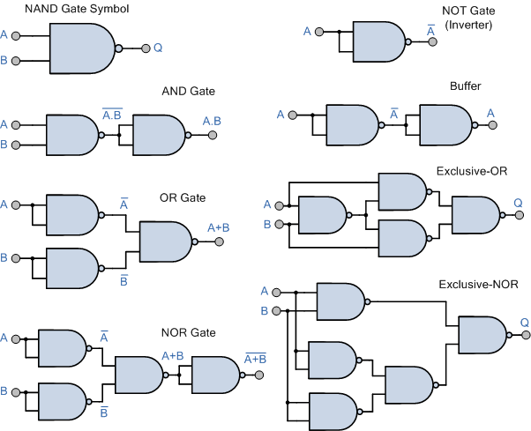**NAND gate as universal gate**

*By using only NAND gate we can implement every other gates as shown above. So, NAND gate is called universal gate.*

**NOR gate as universal gate**

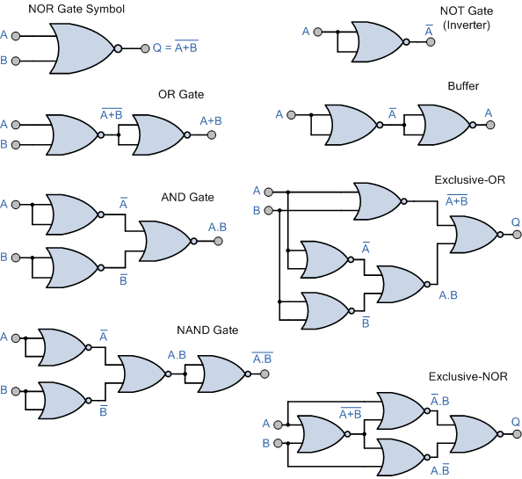

*By using only NOR gate we can implement every other gates as shown above. So, NOR gate is called universal gate.*

1. Subtract ${ 675.6 – 456.4 using both {10}^{'}s and 9^{'}s complement .}_{}$

Ans: Given A is 675.6 and B = 456.4.

**9’s Complement**

First, Finding the 9’s complement of B

9 9 9 . 9

- 4 5 6 . 4

--------------------------------------------------------

5 4 3 . 5

Now Add this 9's complement of B to A

1 1 1

6 7 5 . 6

+ 5 4 3 . 5

-------------------------------------------------------

1 2 1 9 . 1

The left most bit of the result is called carry and add it to the rest part of the result 219.1.

2 1 9 . 1

+ . 1

-------------------------------------------------------

2 1 9 . 2

***So, the answer is 219.2***

**10’s Complement**

First finding the 9's complement of 456.4

9 9 9 . 9

- 4 5 6 . 4

-------------------------------------------------------

5 4 3 . 5

Now adding 1: 543.5 + 0.1 = 543.6

Now, Adding this 10's complement of B to A

1 1 1

6 7 5 . 6

+ 5 4 3 . 6

-------------------------------------------------------

1 2 1 9 . 2

The left most bit of the result is called carry and it is ignored.

***So the answer is 219.2***

1. Which gates can be used as inverts in addition to the NOT gate and how?

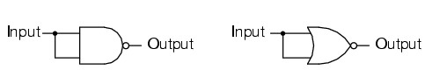Ans: An invertor or logic NOT gate can also be made using standard NAND and NOR gates by connecting all their inputs to a common input signal. For example;

2input NAND gate equivalent 2input NOR gate equivalent

A very small inverter can also be made using just a single stage transistor switching circuit as shown:

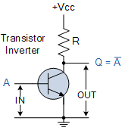

When the transistors base input at ‘A’ high, transistor conducts and collector current flows producing a voltage drop the resistor R there by connecting the output point at ‘Q’ to ground. Thus, resulting in a zero voltage output at ‘Q’ .

Likewise, when the transistors base input at ‘A’ is low, the transistor no switches ‘off’ and no collector current flows through the resistor resulting In an output voltage at ‘Q’ high at a value near to +V cc.

Then, with an input voltage at ‘A’ high, the output at ‘Q’ will be low and an input voltage at ‘A’ low the resulting output voltage at ‘Q’ is high producing the complement or inversion of the input signal.



$. Prove that:$

$$a) \underline{ABC}((\underline{A+B+C})) = ABC$$

$$b) A+\underline{B}C (A+\underline{\underline{B}C ) }=A$$

Ans: **Solution(a)**

LHS: $\underline{ABC}((\underline{A+B+C}))$

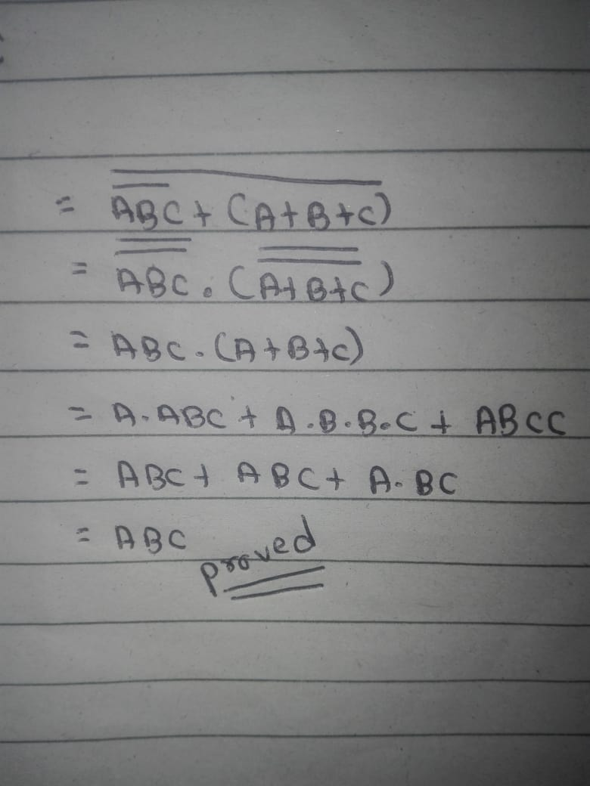

**Solution (b)**

LHS: $A+\underline{B}C (A+\underline{\underline{B}C ) }$

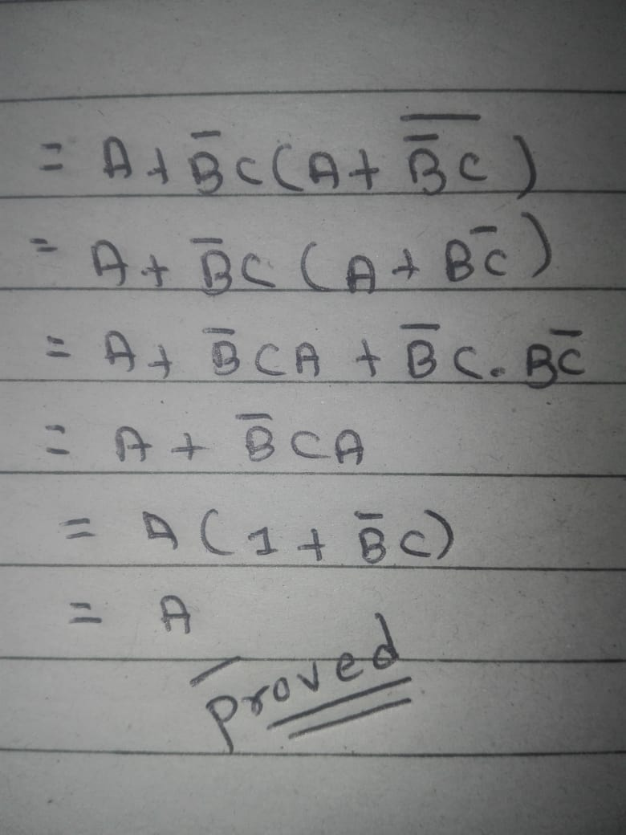

1. Convert the following:

$a) A08E.FA_{16}= {(?)}_{16}$

$$b) AE9.{BOE}_{16}= {(?)}_{2}$$

Ans: **Solution(a)**

At first converting hexadecimal number to decimal

= 10*16^3 + 0*16^2 + 8*16^1 + 14*16^0 + 15*16^-1 + 10*16^-2

= (41102.9765625)10

Now, converting decimal to octal where integer part is 41102 and fractional part is 0.9765625

**For Integer Part**

|  |  |  |  |  |  |  |
| --- | --- | --- | --- | --- | --- | --- |
| **Number** | 41102 | 5137 | 6422 | 80 | 10 | 1 |
|  | **8** | **8** | **8** | **8** | **8** | **8** |
| **Reminder** | 6 | 1 | 2 | 0 | 2 | 1 |

**For Fraction part**

0.9765625

*8

-------------

7.8125

*8

-------------

6.5

*8

-------------

4.0

Therefore, the given number in octal form is (120216.764)8.

**Solution(b)**

Here, integer part = AE9 and fractional part = B0E

At first converting hexadecimal to decimal

= 10*16^2 + 14*16^1 + 9*16^0 + 11*16^-1 + 0*16^-2 + 14*16^-3

= (2793.690917)10

Now, Converting this in Binary system

**For Integer Part**

|  |  |  |  |  |  |  |  |  |  |  |  |  |
| --- | --- | --- | --- | --- | --- | --- | --- | --- | --- | --- | --- | --- |
| **Num** | 2793 | 1396 | 698 | 349 | 174 | 87 | 43 | 21 | 10 | 5 | 2 | 1 |
|  | **2** | **2** | **2** | **2** | **2** | **2** | **2** | **2** | **2** | **2** | **2** | **2** |
| **Rem** | 1 | 0 | 0 | 1 | 0 | 1 | 1 | 1 | 0 | 1 | 0 | 1­ |

**For Fractional Part**

0.690917

*2

-------------

1.38184

*2

-------------

1.52734

*2

-------------

1.05469

*2

------------

0.10938

*2

-----------

0.21875

*2

-----------

0.4375

*2

-----------

0875

*2

-----------

1.75

*2

------------

1.5

*2

------------

1.0

*Therefore, the binary form of the given number is 101011101001.10110000111*

1. Convert the following hexadecimal number to decimal and octal numbers. a) 4FF b) 6FED

Ans: **Solution(a)**

*Converting into decimal*

4FF(16) = 4*16^2 + 15*16^1 + 15*16^0

= (**1279**)10

*Converting into Octal*

|  |  |  |  |  |
| --- | --- | --- | --- | --- |
| **Number** | 1279 | 159 | 197 | 2 |
|  | **8** | **8** | **8** | **8** |
| **Reminder** | 7 | 7 | 3 | 2 |

Therefore, the given number in octal form is (**23377**)8.

**Solution(b)**

Converting into decimal

6FED(16) = 6*16^3 + 15*16^2 + 14*16^1 + 13*16^0

= (**28653**)10

Converting into octal

|  |  |  |  |  |  |
| --- | --- | --- | --- | --- | --- |
| **Number** | 28653 | 3581 | 447 | 55 | 6 |
|  | **8** | **8** | **8** | **8** | **8** |
| **Reminder** | 5 | 5 | 7 | 7 | 6 |

Therefore, the given number in octal form is (**67755**)8.

**-END-**